STATION #____: CONTROLLED RIDING, RIGHT TURN & STOP 10/05

Skills this station teaches:
- Riding in a straight line and stopping in a controlled manner
- Executing right turns at a corner after checking for cross traffic
- Avoiding obstacles in a controlled manner without excessive swerving
Why do this? Riding predictably is key to avoiding collisions with cars. This includes controlling one’s bike, communicating with other road users and following the rules of the road.

STATION LEADER Instructions:
- Have students line up their bikes as indicated and quickly come forward to the “START” line on foot. Help those without helmets feel included, noting that they can walk/jog through as if they are on bikes, learning skills they can practice at home.
- Explain what they'll be learning at this station and why (see above), but keep your explanation short – students will learn best by practicing.
  - Ask a volunteer to demonstrate hand signals with his/her back to the children (see refresher on next page). Have the students quickly practice right, left and stop signals.
  - Ask them if just using a hand signal makes it safe to turn. (Answer: Need to check traffic.)
- Have students watch while one of the volunteers jogs through the course as if on a bike, demonstrating each point as you explain:
  - "Start by riding straight, staying in the bike lane." (Indicate the left side of the course.)
  - “Just before you get to the other end of the course, signal a right turn, look for traffic (left, right, left), and then make the turn."
  - "When you come back up the other side, you'll have to avoid these obstacles while still staying in the bike lane." (Show sponges.)
  - "Signal a stop, and brake to a safe stop at this line." (Point out the stop line at the end of the course.) "Then get back in line for your next turn.”
- Have the children get on their bikes. For the first group, assist with working out partners for children with helmets but not bicycles. Sharing bikes works more smoothly if partners do not stand together but with 3 students in between.
- As the students go through the course, observe them from the middle of the course as indicated in the diagram. As each child comes back toward the start, offer specific praise and guidance on what to work on next time.
  - Focus first on control of the bike (staying in the lane, keeping a safe distance from the other riders, making a controlled turn, avoiding sponges and braking to a safe stop.
  - Also make sure they check for cross traffic by looking left, right, left. Gently remind those who forget that they must look to be sure it's safe to turn!
  - Finally, encourage proper use of hand signals, but remember that control of the bike must come first. Signals let other people on the road know what they plan to do, which is good, but some third graders have difficulty controlling their brakes one-handed. Praise progress and urge them to keep practicing at home.
- When it's time to rotate to the next station, remind the children that it’s important to practice what they’ve learned about controlled riding, using signals and checking for traffic whenever they ride on the street. Then make sure the children walk their bikes to the next station.
STATION #____: CONTROLLED RIDING, RIGHT TURN & STOP 10/05

Volunteer Instructions

At least two volunteers are needed at this station.
Volunteer at the beginning of the course.
  - Organize the students into a line as they arrive. Ensure that walkers participate; space out bike sharing partners.
  - Start each student clockwise through the course, spaced so that one starts when the other has made the right turn.
  - Make sure that they stop safely at the line when they come back to the end of the course, but then get out of the way of the next child.
  - Gently remind all but the most flustered cyclists to use their stop signal prior to braking and stopping.
  - Keep the line from interfering with the end of the station while children wait.

Volunteer at the opposite end.
- Help with the hand signal demonstration (with your back towards the students). Also demonstrate what the students do here by walking through while the station leader explains — this really helps the kids "get it".
- Help keep students on course as they turn (so they don’t turn too soon).
- Have them make their right turn signal before they actually start turning (but be gentle with wobbly riders).
- Gently remind those who forget to check for traffic by saying “What’s the most important thing to do before turning?" Commend those who remember to look left, right and left again before turning.

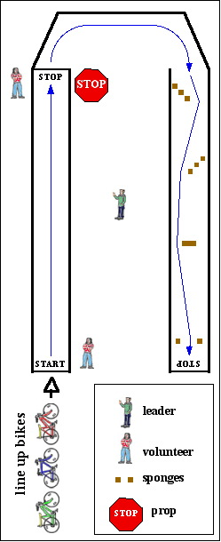

Here's a brief refresher on hand signals:

Right Turn
Make an "L" with left arm OR extend right arm straight out. Either is legal in California. For many children, using the left arm for all signals works best, but experienced cyclists prefer the right arm out signal.

Left Turn
Extend left arm straight out from shoulder.

Stop
Hold left arm out with forearm down at a 90-degree angle.
Signals should be given before making the turn or putting brakes on. Third graders should have both hands on their handlebars when turning for better control.

