STATION #____: SCANNING & MOVING LEFT STATION LEADER GUIDE 10/07

Skills this station teaches:
- Scanning back over the left shoulder without swerving.
- Moving left only after checking behind you to be sure it's safe.
Why do this? Moving left without looking back is a major cause of serious bike/car crashes. Most third graders can master the skill of scanning without swerving after a few minutes of practice.
Note: this is only the first part of learning how to turn left. Besides scanning, a safe left turn involves moving left in the traffic lane and checking for on-coming as well as cross traffic.

Station Leader Instructions [see diagram on next page ]
- As students arrive at station, have them quickly line up their bikes single file on arrows, then leave their bikes in line and come stand by the word “START”. This and keeping the explanation to 3 minutes helps maximize practice time.
- Briefly explain what they'll be learning at this station and why – see above. Ask: "What would you do if you are riding a bike and suddenly there's broken glass right in front of you?”
  - Respond to answers like "go around" or "signal" by asking: "Okay, but what do you need to do FIRST?" (Answer: Check for cars.)
  - Have students practice scanning, following lead of demonstrator. Ask them to touch their left shoulder, then hold out their hands as if on handlebars and scan to the rear over their left shoulder. Explain that the secret is riding straight to keep shoulders straight and square with the handlebars while looking over their left shoulder.
  - Have your car prop volunteers show the image of the vehicle, and ask the students to shout “CAR!”. Then when they see the blank side, ask them to shout “NO CAR!”
- Explain that they will practice scanning in 3 different places as they ride in a bike lane:
  - At the first place marked LOOK, they are just checking if there's a car coming or not. There’s no need to stop, but they do need to shout CAR or NO CAR. Pause here to observe the demonstrator.
  - "When you see the second LOOK, you want to cross the street. So you check over your shoulder again. Shout CAR or NO CAR, but only go across if there’s no car coming!"
  - "On your way back, you'll find a hazard in the bike lane — but before you go around it, you will need to scan again. Be sure there are no cars before you make your move!"
- Then have the children get back in line and ride through the course, spaced so that a child starts the return leg before starting the next child. Work out partners for those with helmets but no bikes. Children without helmets walk through as if on bikes. You stand at the start of the course and cue them about what they’ll be doing.
- On the first pass focus on the critical new skill: scanning back while riding straight. Emphasize that they need to shout CAR or NO CAR. Most children will just look at first.
  - Help the next child in line observe what the child ahead of them does at the opposite end of the course. Make clear that at the second LOOK, they do need to stop if they see a car behind them, because it’s not safe to cross. Similarly, the coast should be clear before they go around the obstacle on the return leg of the course.
- On subsequent passes, keep emphasizing the 3 different scans and the key point: move left only when they see no car behind them. Add the left turn signal at the opposite end and vary whether or not the volunteers show or hide the car props. Emphasize that "scanning" behind is an important safety skill to use every time before moving left.
STATION #____: SCANNING & MOVING LEFT VOLUNTEER GUIDE 10/07

Volunteer Instructions
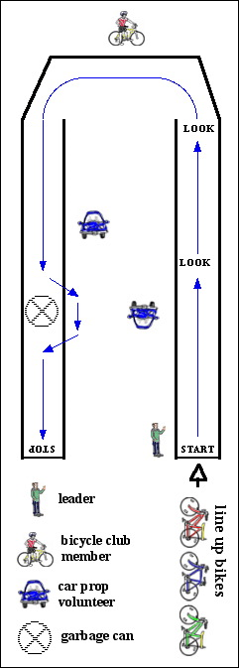
At least three volunteers are needed at this station in addition to the station leader.

Volunteer demonstrator (from Stanford Cycling Club)
  - Serve as a model when the station leader asks kids to practice scanning. Stand in the bike lane at the beginning of the course with your back to the children, and hands on handlebars. Scan over your left shoulder, holding shoulders straight and square with the handlebars. Cyclists who do this don't swerve while scanning.
  - Then, as the station leader explains what you are doing, model how to ride through the course.
    - Scan when your wheel goes over the chalked word LOOK and then shout CAR or NO CAR depending on what you see.
    - Scan again at the second LOOK and before the obstacle — and don't move left until the coast is clear.
    - Even if you don't have a helmet and bike, demonstrate as if you do — it really helps kids "get" what to do.
  - While children ride through, you stand at the far end of the course to give feedback to the kids.
- Help each student make the connection between what they SEE at the second look (Car or No Car) and what they DO (stop until it’s clear, or keep on going). Be sure to stop them if they’re about to turn in front of a car!

Two volunteers with car props, as if they are cars going in each direction on a street
- While station leader explains, show the students what to look for when students scan back over their left shoulder: the front of your car prop (meaning they should shout “CAR”) or the blank side (“NO CAR”).
- Then stand at the designated points with car props and assist with the demonstration by the cyclist.
- Start by showing the car at all three points where students scan. On later passes, challenge good cyclists by varying whether the coast is clear. Be gentler with others.
Discourage peaking by letting them go by you before you hold up or hide your prop.
- Do not talk to the children as they ride by – you are a car! Station leader and demonstrator will be giving the students feedback.
- Ham it up with horn sound effects or squealing brakes to emphasize the consequences if a child starts to move left when you’re showing the car at the second LOOK or at the obstacle and the child doesn’t scan, and then stop until the coast is clear.

